Week #2

Objective: For students to get some practice of:
- Using basic C++ types and user-defined objects
  - Integer Types
  - Basic Integer Operators
- C++ Input and Output
  - Formatting Output
  - Reading from the keyboard
- Named constants
- Expressions

Programming Exercise:
Use setw(width) manipulator for formatting output where required.

Write a program that read two integers from the keyboard and print their sum and average.

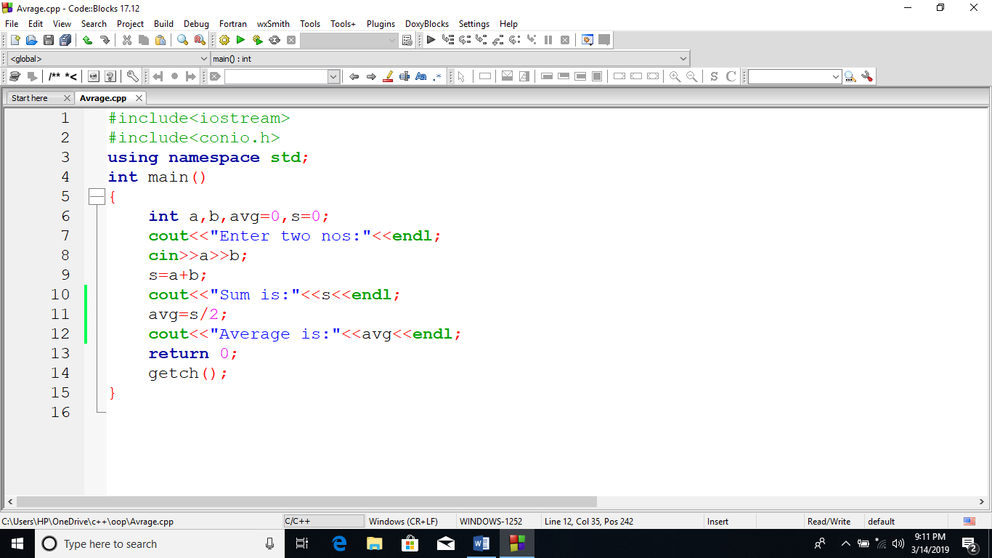
OUTPUT:
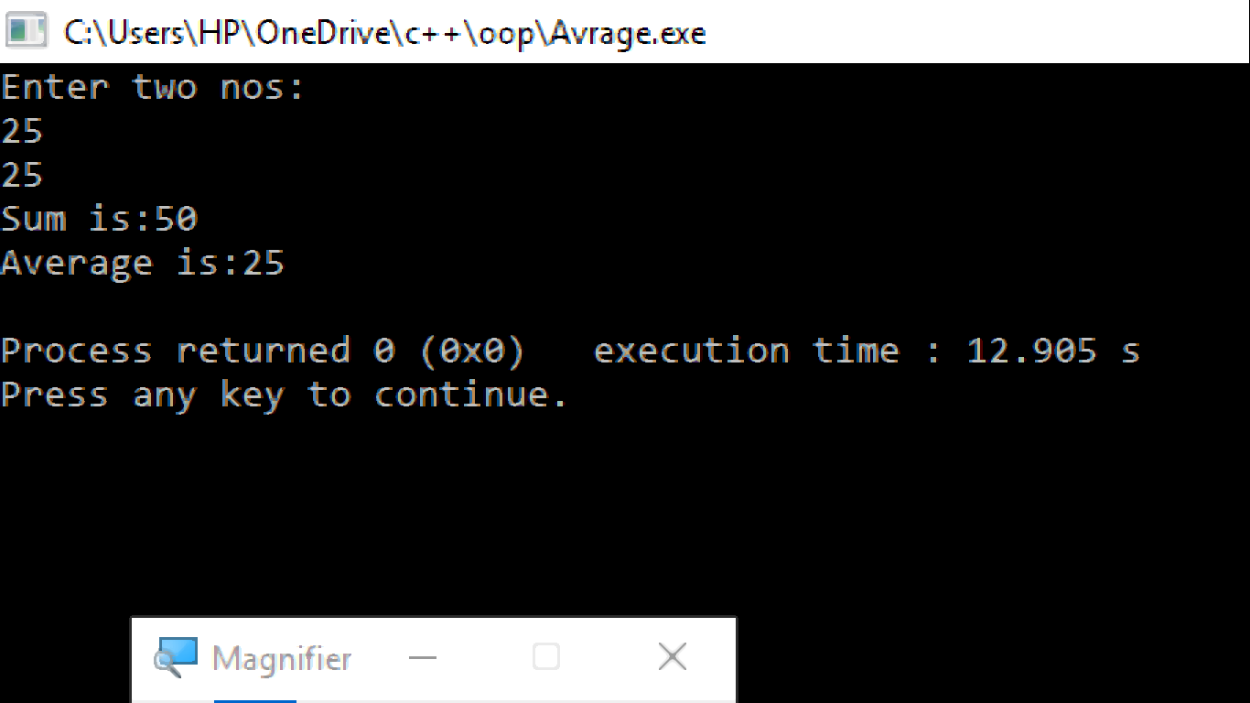

Write a program that prompts for a person’s height in inches. Convert this height measurement into feet by using the conversion factor of foot2Inch= 12 inch. Now, the value obtained can easily, be translated into feet and inches which are then output by the program.

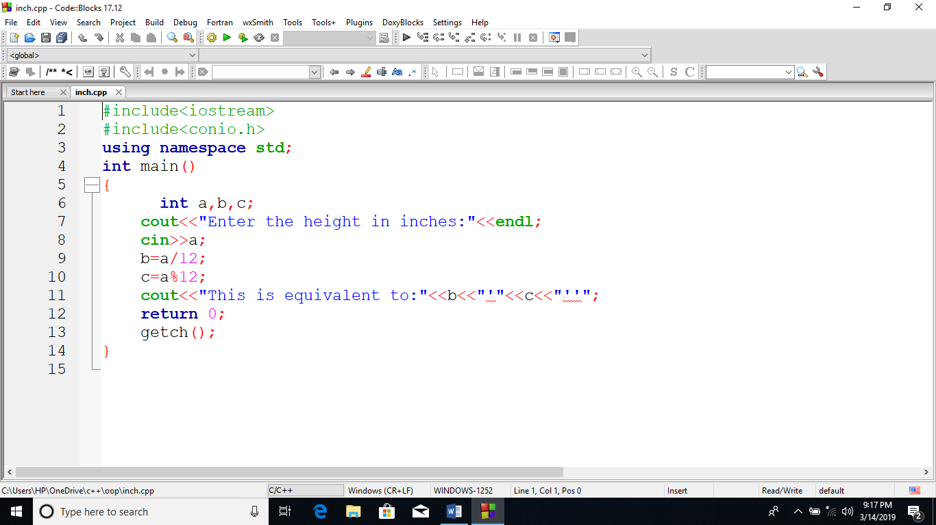
OUTPUT:
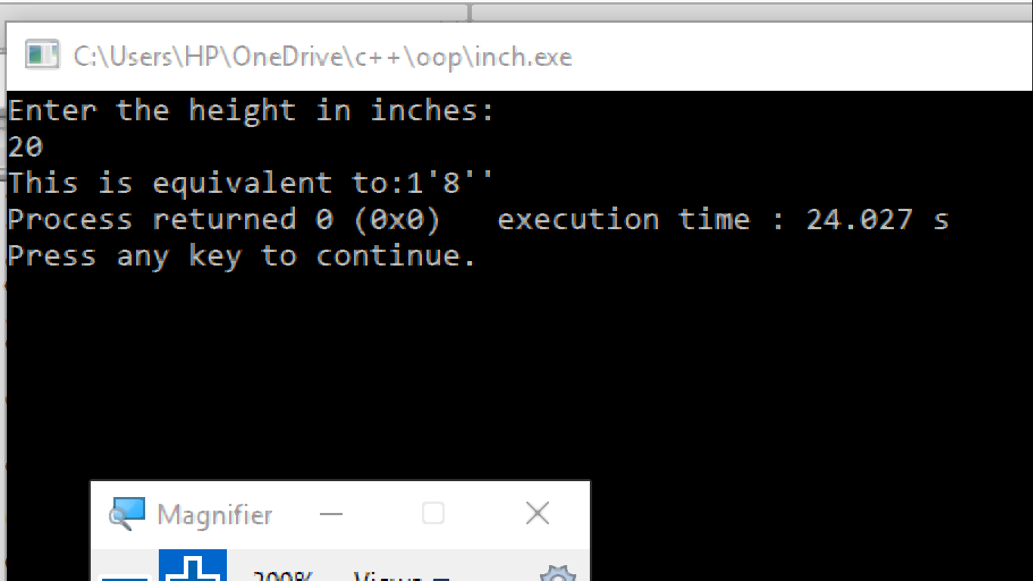

Write a program that prompts for time in seconds and output that time in hours, minutes, and seconds. Here student will learn the usage of divide and modulus arithmetic operators in integers.

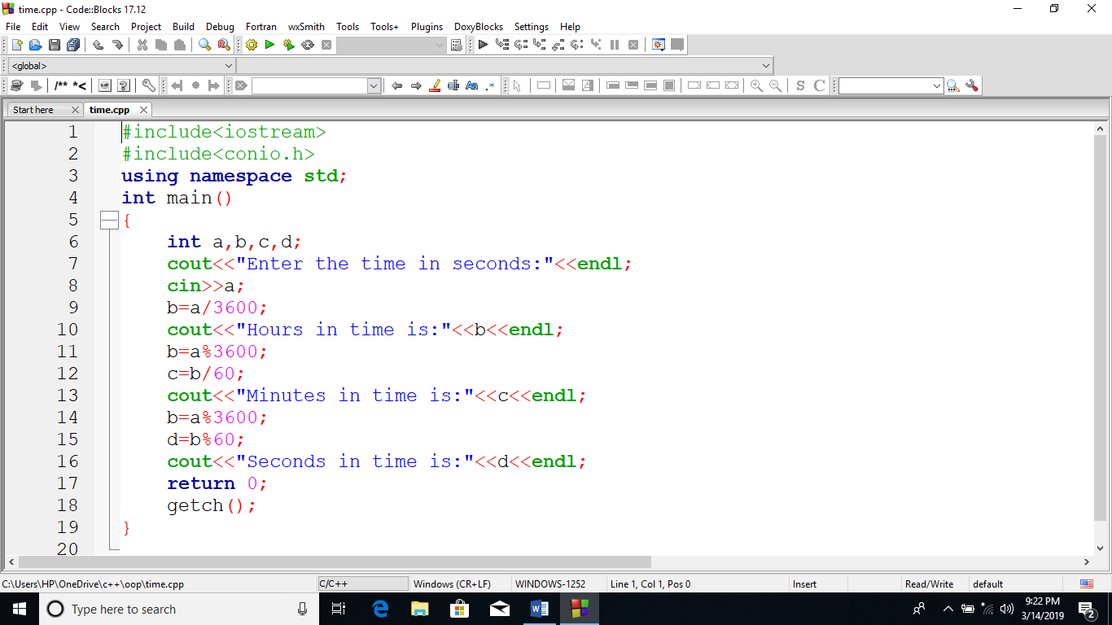

OUTPUT:
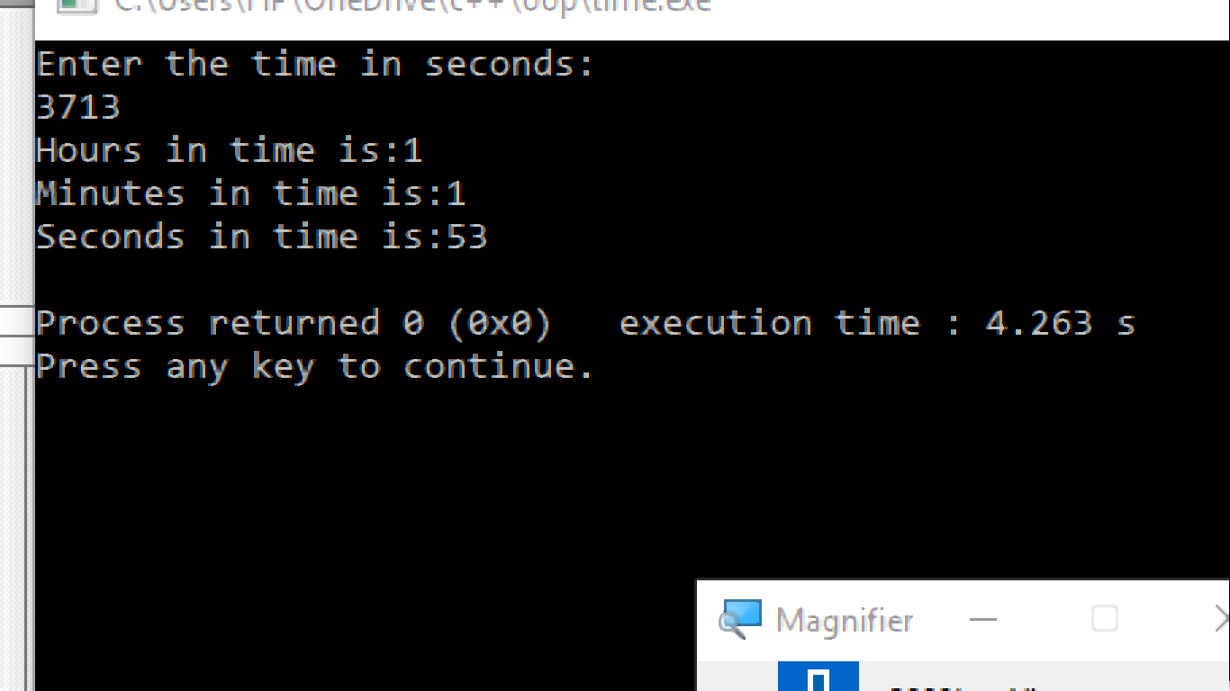

Write a program that prompts for amount in rupees and show how many 1000’s, 500’s, 100’s, 50’s, 10’s, 5’s, 2’s and 1’s in it.
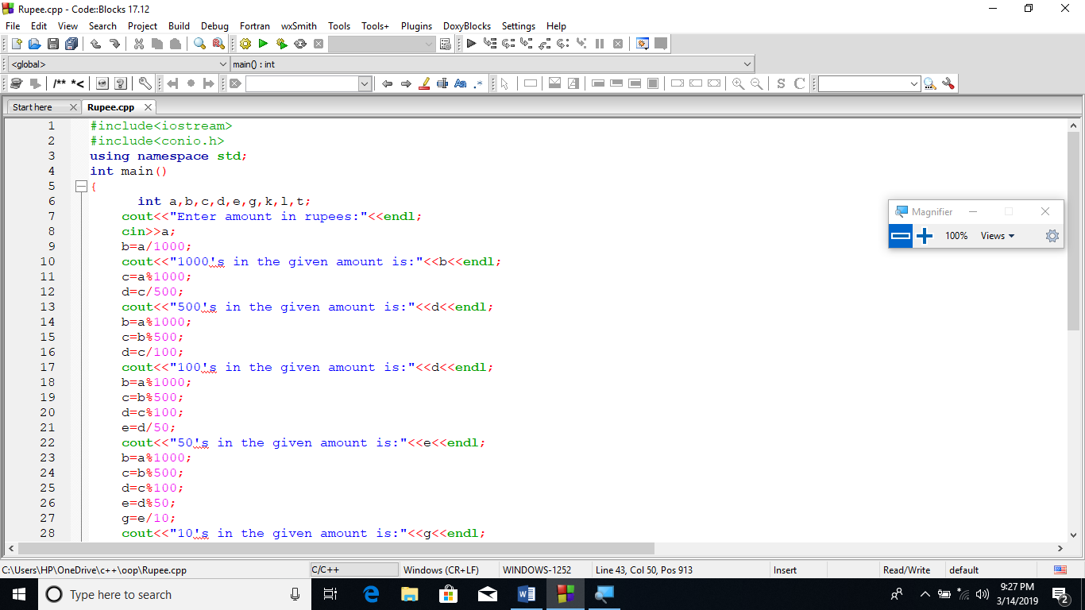
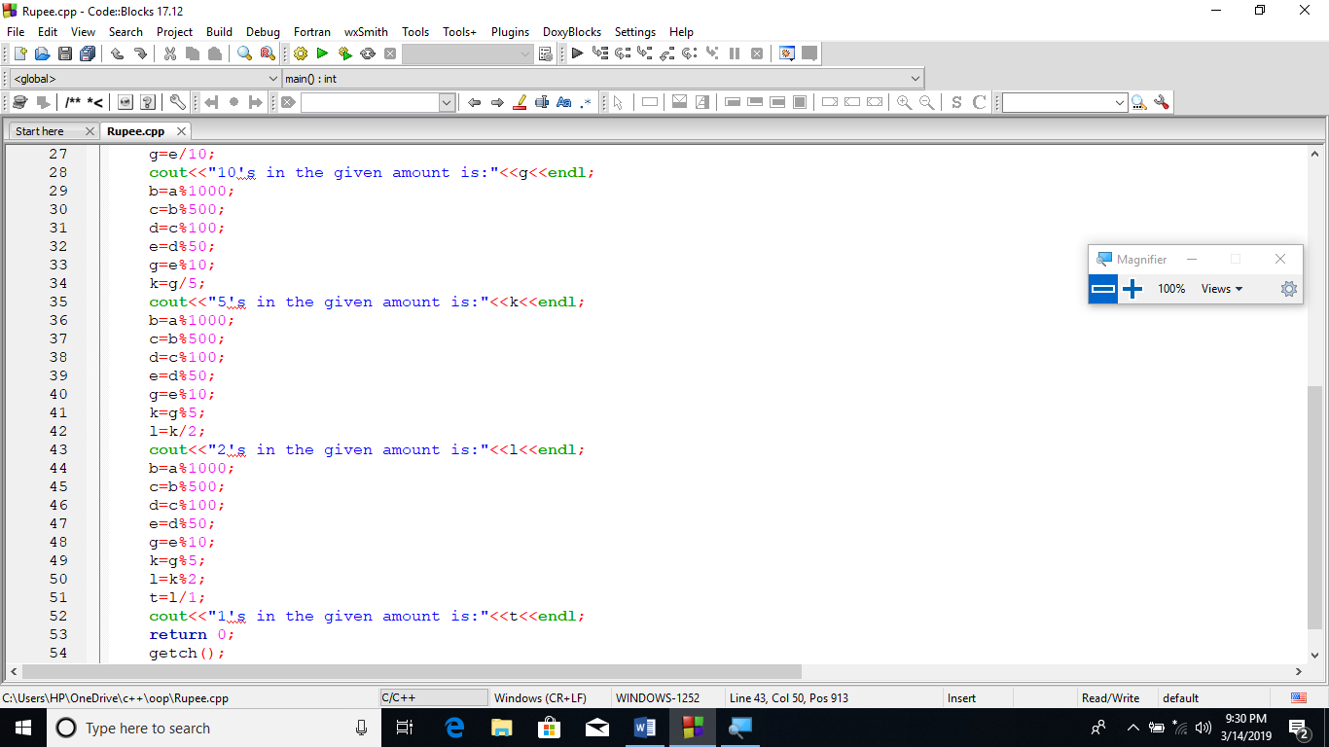
OUTPUT: 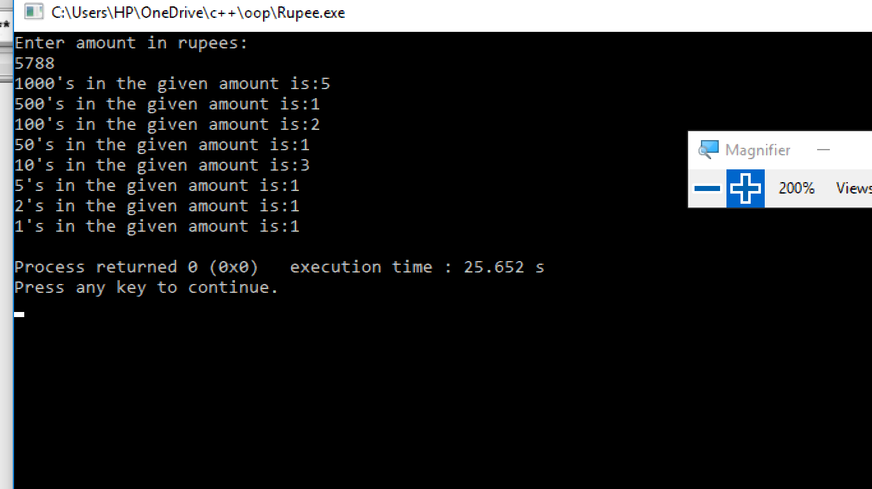

Write a program that calculates the temperature in Fahrenheit. For that it prompts for temperature in Celsius degrees. Formula to calculate Fahrenheit temperature is Fahrenheit=Celsius (9/5+32). Once if the task done do the vice versa i.e. Celsius=5/9(Fahrenheit -32)

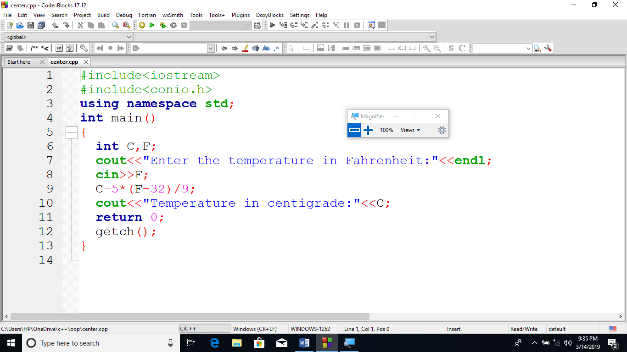

OUTPUT:
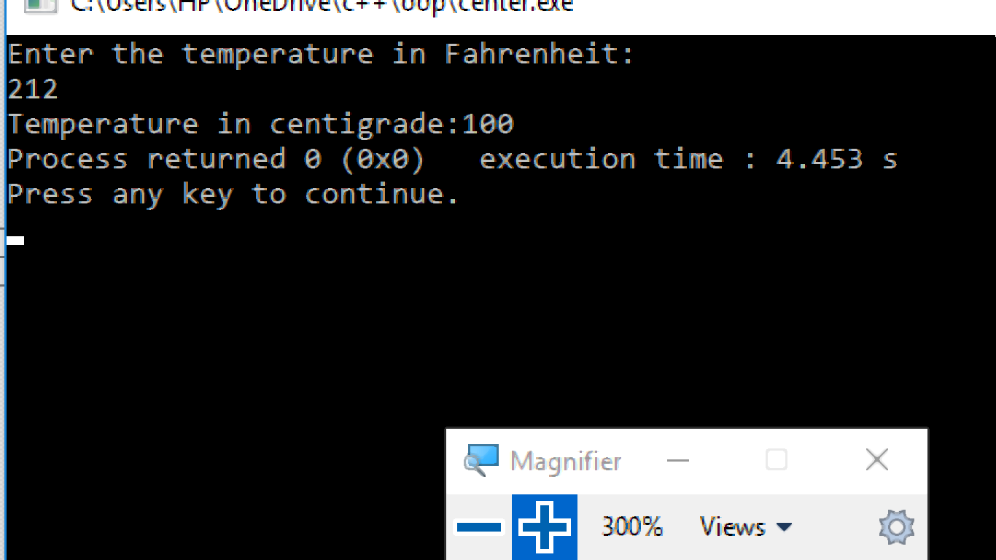
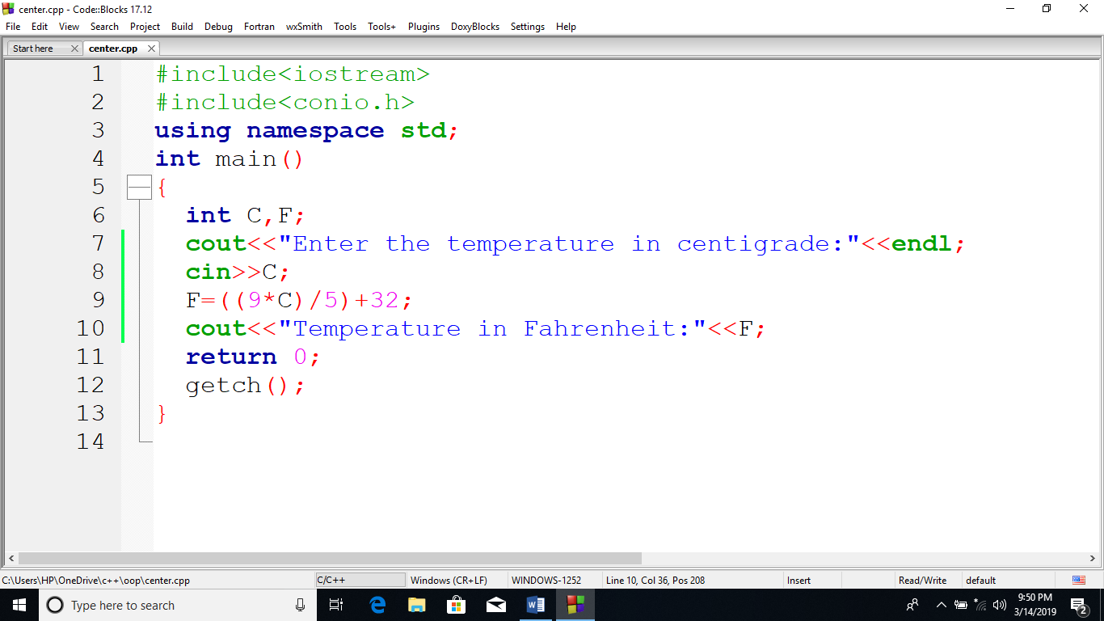
OUTPUT:

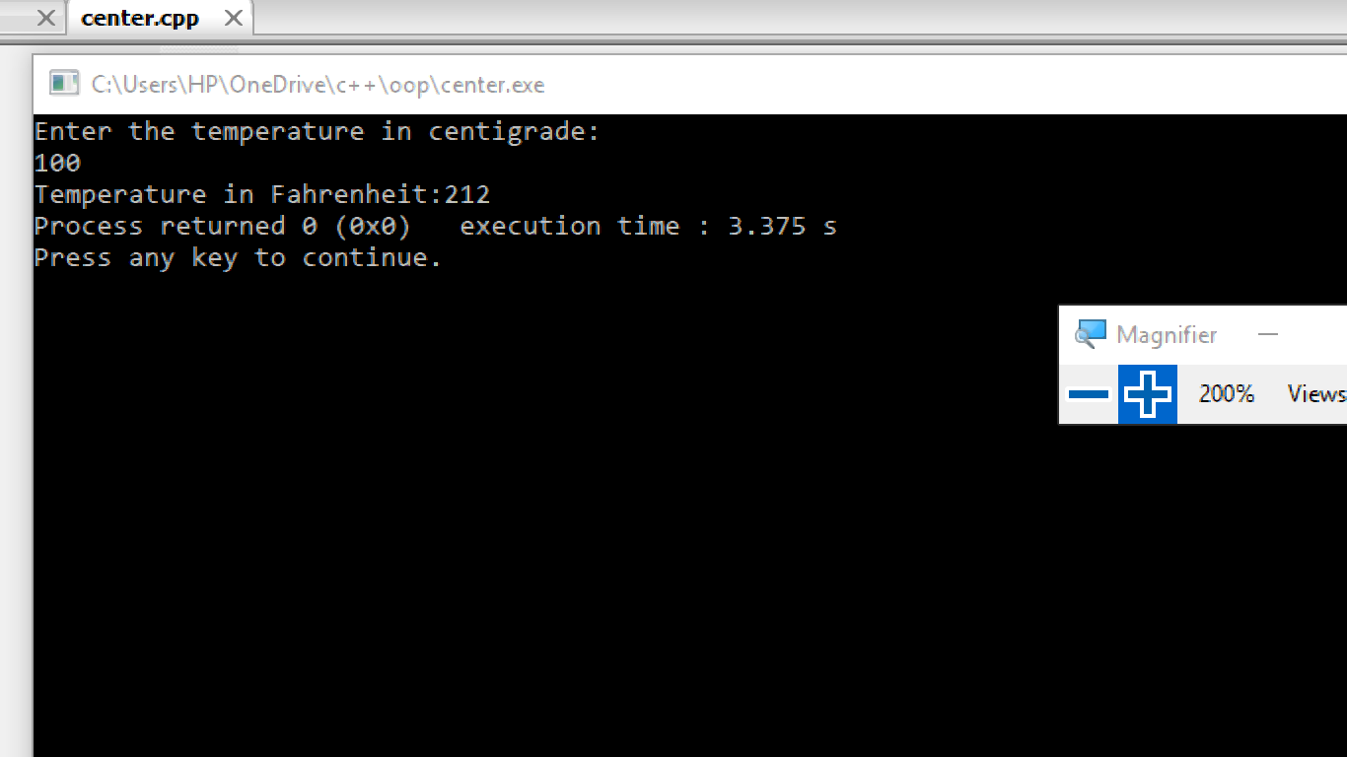

Write a program that inputs a two digit integer value, and output its reverse order.
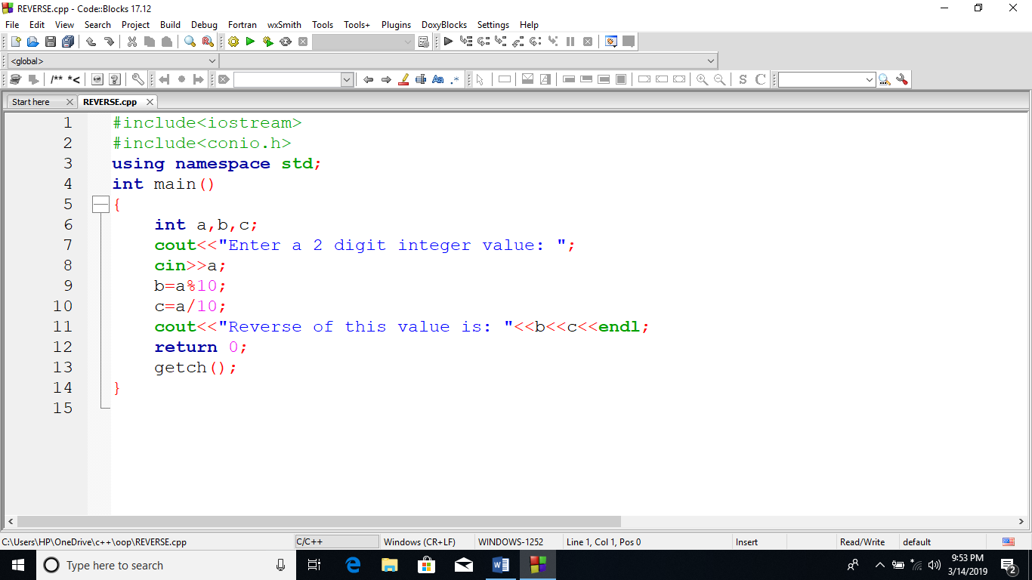
OUTPUT:
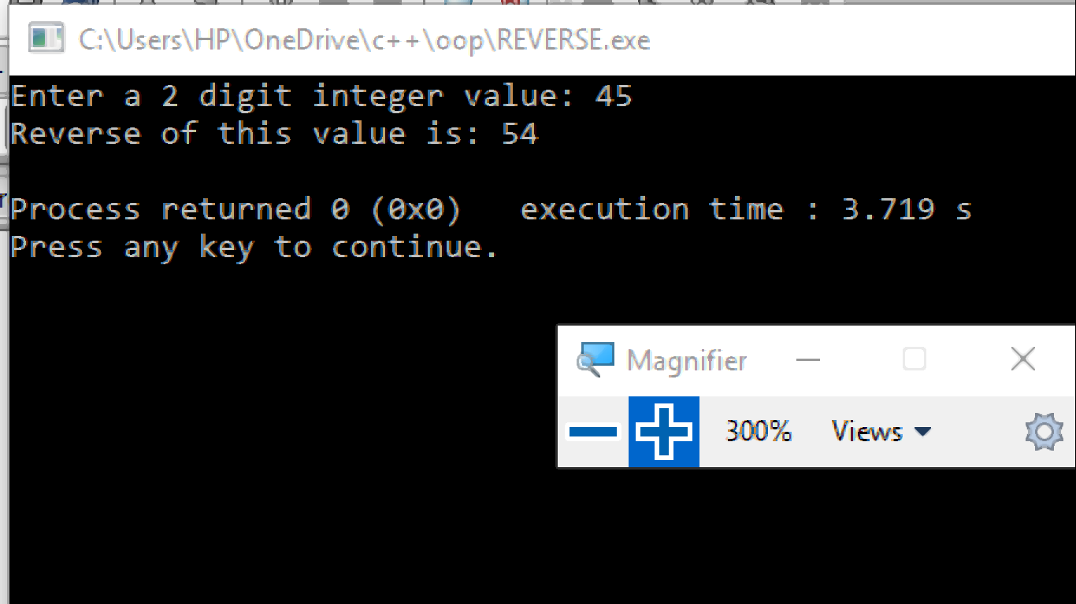

Write a program that reads the two digit nmber as two characters chTen and chUnit and convert that two digit number into an integer value. In order to compute the corresponding integer value, each character must be converted to the digit in the range 0 to 9. this is done by subtracting 48(‘0’) from the ASCII value of the character.

ValueTen=chTen-‘0’; // ’8’-‘0’ is 8

ValueUnit=chUnit-‘0’; // ’2’-‘0’ is 2

To create integer value fro m, the positional value of each digit must be used. In this case multiply ValueTen by 10.

M=ValueTen*10+ValueUnit;//m=8*10+2=82

Sample run:
Enter a two digit number: 82
Numeric Value is: 82

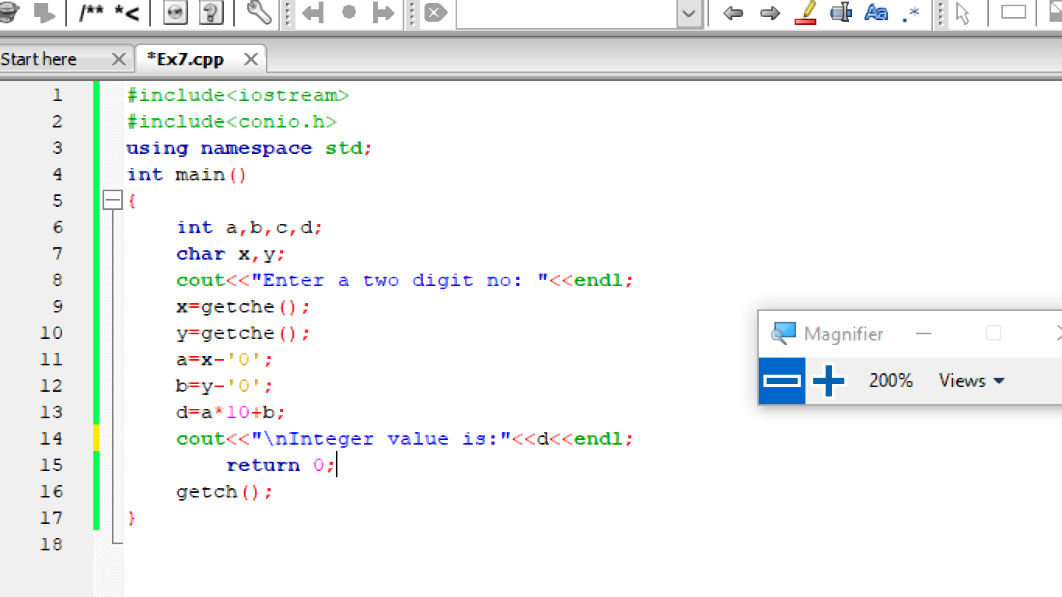
OUTPUT:
